Nested Tri-Flex Loop™ Worksheet

Any number of Tri-Flex Loops can be grouped to reduce installation space requirements. There are several factors to consider during the layout design. By completing this sheet, we will be able to determine the necessary factory modifications required to the outer Tri-Flex Loops in order to assure each is free to move as required. If there are other obstructions (i.e. framing or equipment) their location should also be noted on the sketch. The “A” and “B” dimensions will be provided by Flex-Hose Co., all other information is to be completed by the Engineer or Contractor.
SPECIAL NOTE: L1A is always the innermost Tri-Flex Loop.

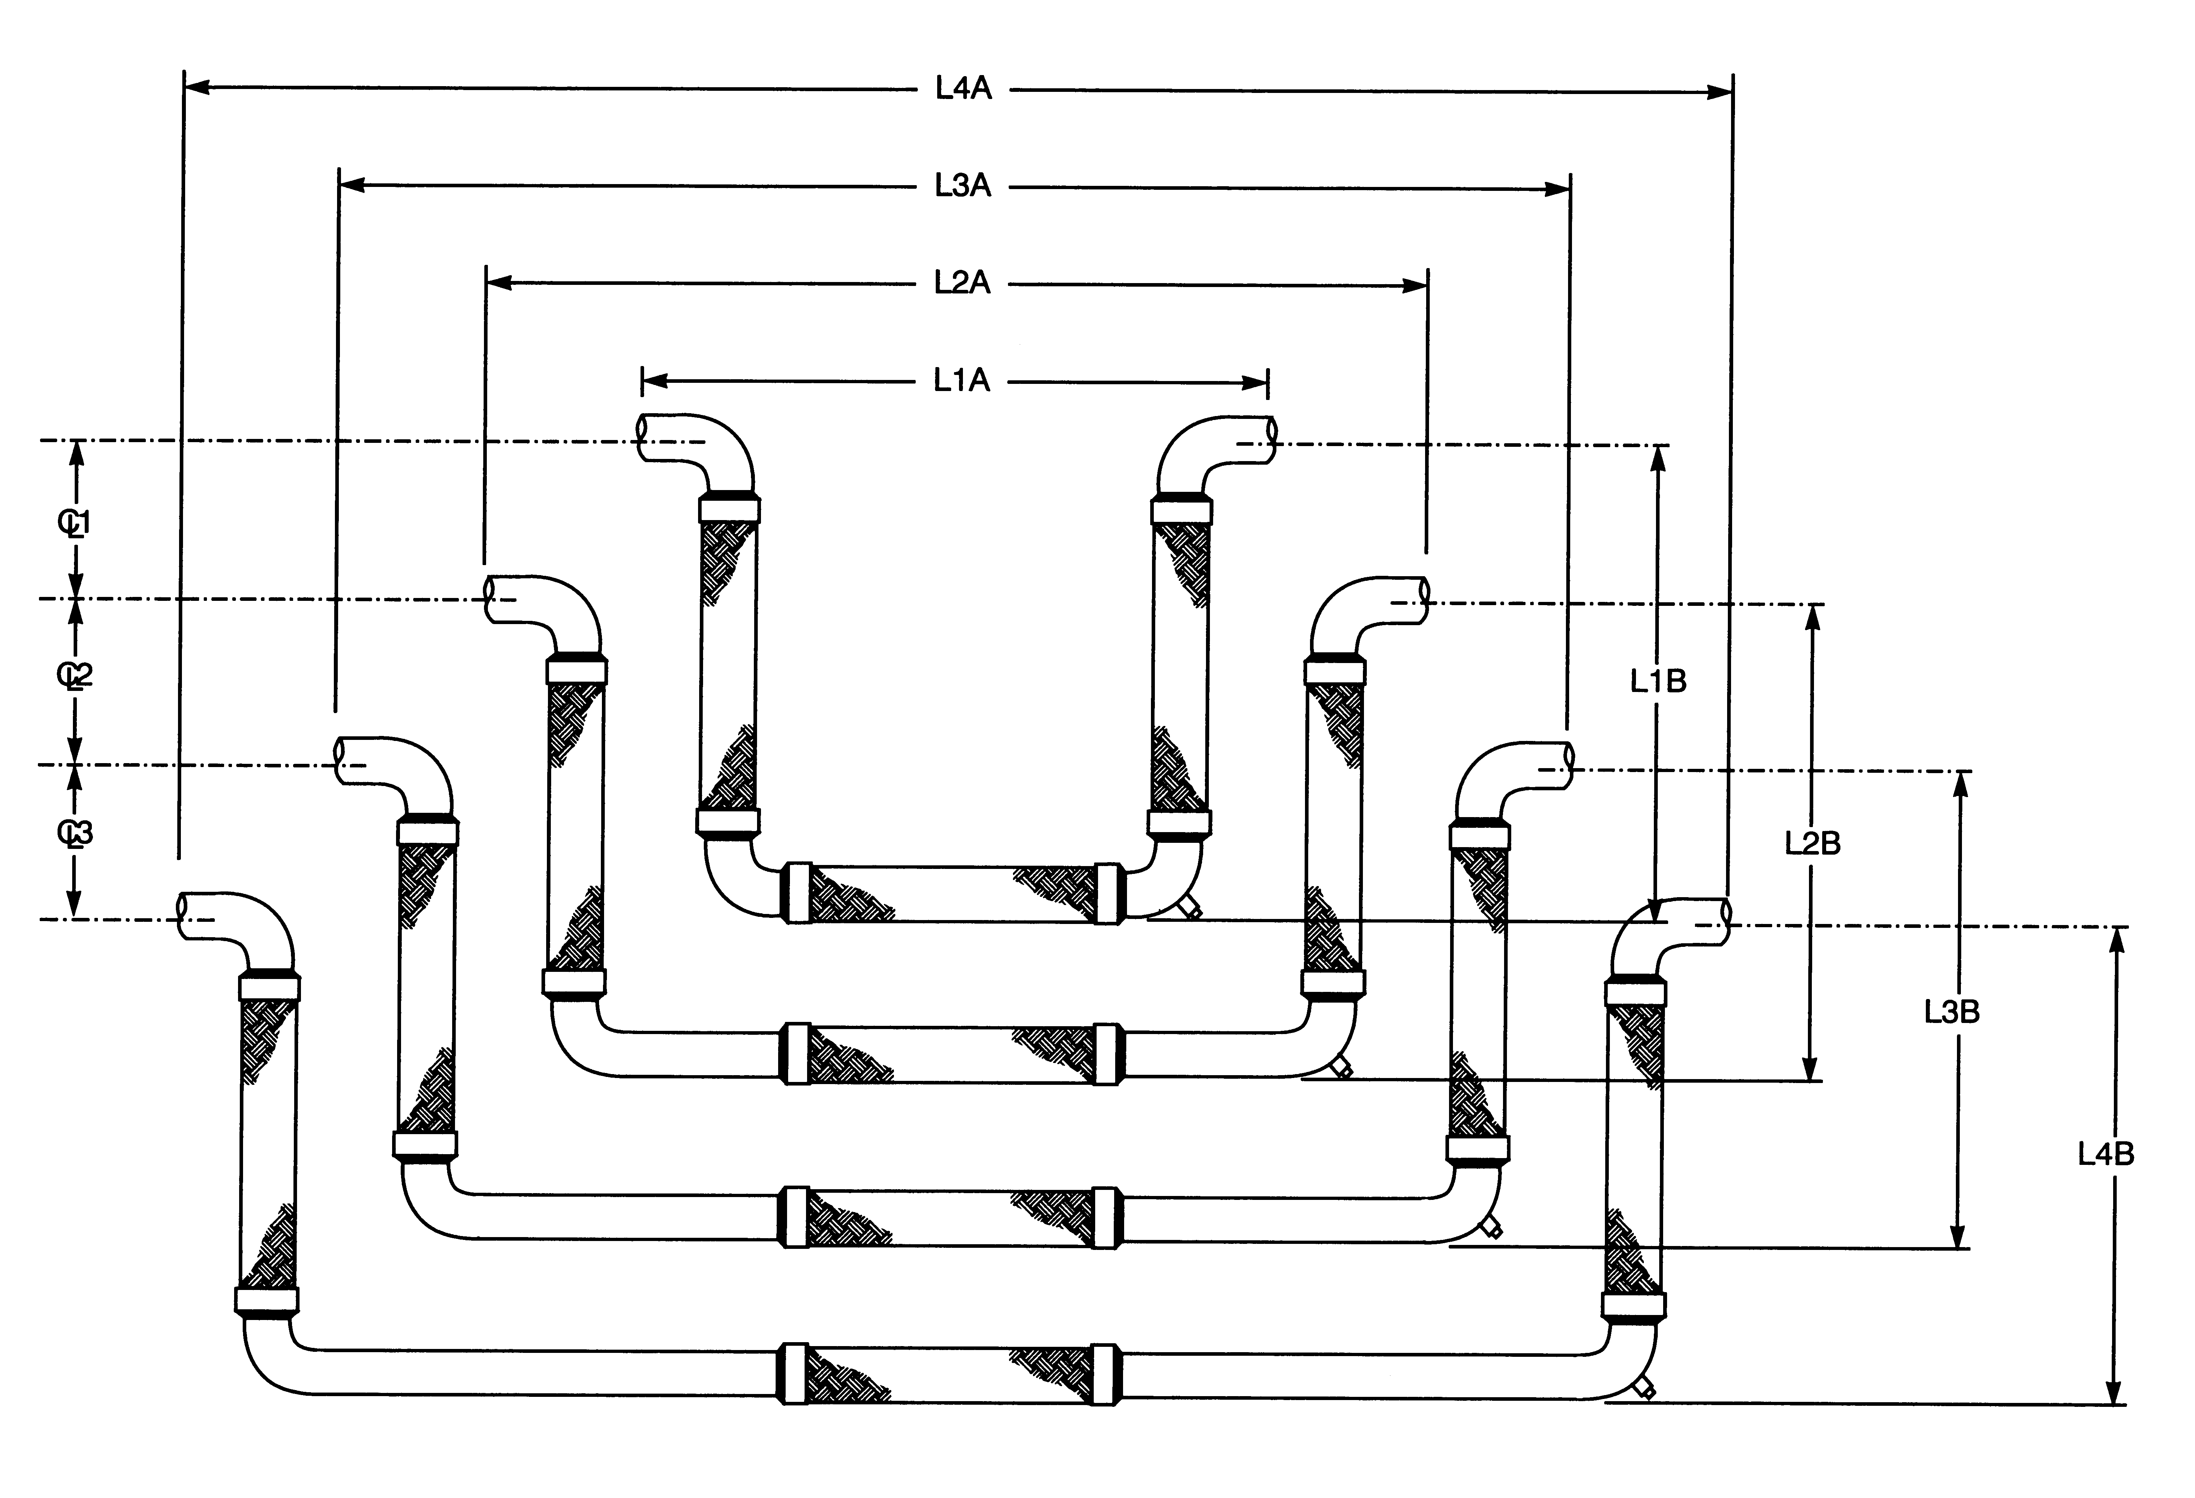

Location of nest and any special notes:

Tag | Pipe Size | End Fitting | Media | Movement | Maximum Service |  | Insulation Thickness | “A”  End to End | “B”  Center of Pipe to Bottom of  Tri-Flex Loop | Centerline Distance Between Pipe Lines
 |  |  |  |  | Temp °F | PSI
 |  |  |  |  |  |  |  | L1A | L1B | CL1
 |  |  |  |  |  |  |  | L2A | L2B | CL2
 |  |  |  |  |  |  |  | L3A | L3B | CL3
 |  |  |  |  |  |  |  | L4A | L4B

Customer

Project

Engineer
Architect
Inquiry or P.O.#

